LEonard

Universal Robot QuickStart

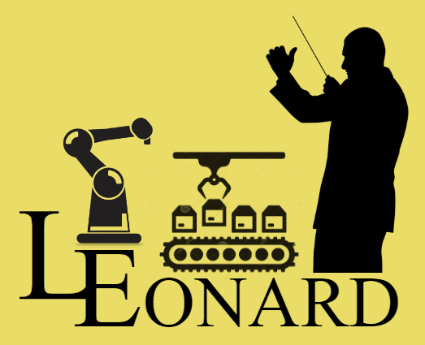



Software Version 22.11.1.0

**LEonard Software by Lecky Engineering, LLC**

|  |  |  |
| --- | --- | --- |
| **Document Version** | **Date** | **Major Additions** |
| 21.11.4.0 | 11/04/2021 | Initial user interface and device management system, Java interpreter |
| 22.04.1.0 | 04/01/2022 | Universal Robot interface and grinding system, LEScript support |
| 22.08.1.0 | 08/15/2022 | LMI Gocator interface and demonstration |
| 22.11.1.0 | 11/14/2022 | Python support, screen sizing and display management |

**CONTENTS**

Overview 4

Install the Software 4

Starting up 4

About the License 4

Display: Get your Screen Sized Right 4

Devices: Let’s start talking to something! 4

An aside: LEonard File Structure 4

# 

# Overview

Welcome! Thanks for choosing LEonard!

# Install the Software

LEonard runs on Windows 10 or 11-based machines.

# Starting up

## About the License

Blah blah

# Display: Get your Screen Sized Right

Blah

Setting up your Devices

# Devices: Let’s start talking to something!

Blahhhhh

### An aside: LEonard File Structure

LEonard is aware of a <LEonardRoot> directory where it is installed. LEonard expects to be executing out of <LEonardRoot>/LEonard/bin.

For you this could be anywhere. Many customers use c:\LEonard.

Beneath this root, several directories are maintained:

* Code: Where the programs you create will be stored by default
  + Examples: Many LEonard example programs
  + Lib: Python and Java code libraries including custom add-on by Lecky Engineering
* Config: Default location for all of the Devices files *.ldev
* Data: A good default directory for input and output data files
* DB: Leaonard database for Displays, Positions, Tools, and Variables. These are stored as simple XML.
* LEonard/bin: The location of the LEonard executables and support fiiles.
* Logs: Where the logfiles are created.
* 3rdParty: Where example programs for 3rd party devices such as the Universal Robot code and code for the LMI Gocator.